

**Payroll System**

**POSEgg006**

HUEVO – FEBRUARY 2017

|  |  |  |
| --- | --- | --- |
| **SCRUM TEAM** | **SPRINT NAME AND DURATION** | **CHANGES** |
| Huevo | POSEgg006  18/Feb/17  to  4/March/17 | * **Employee Information Page** |

**POSEgg006**

This story includes the creation of Employee Information page. The Employee Information Page can view the basic information of the employees. The team are creating employee information page were you users can access add, view and edit to information of employees. The user must go to login page to validate the username and password to provide security of the user.

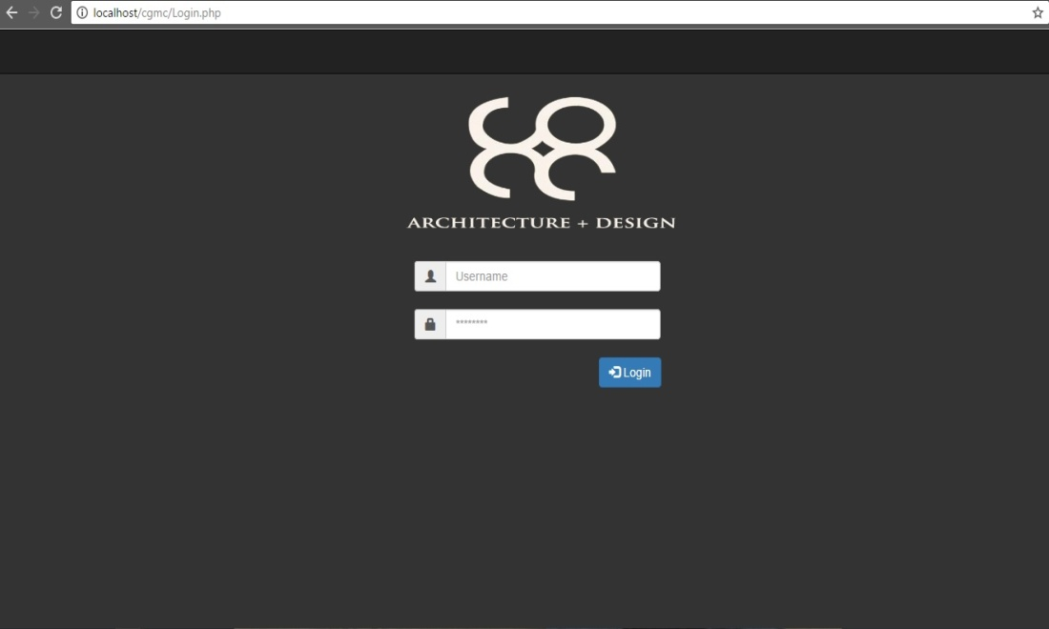

1. Adding Login Page Procedures

Step1: Click Start Button

Step2: Open Xampp and Start MySql , Apache

Step3: Open any available browser

Step4: Browse “localhost/cgmc”

Step5:Click “loginpage.php”

1. Process of Authentication Procedures

Step1: Insert Valid Credentials (Username, Password) then click the login button

1. Adding employee tabs and category, the user must able to access the adding employee were the admin can input the basic information about new employee and must able to create a new record of employee. The user can also fill all the tabs. Procedures are:

Step1: Click the add employee button

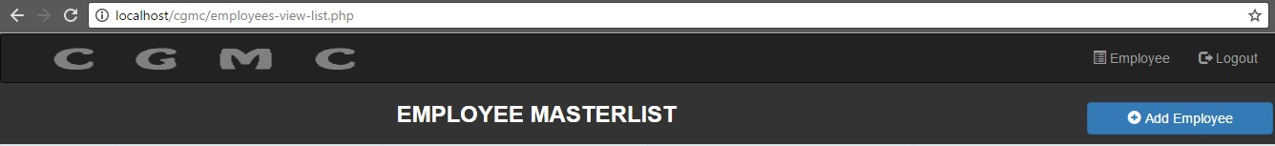

Step2: User are required to fill up all the tabs, every tab has its category 1st tab Official Information.

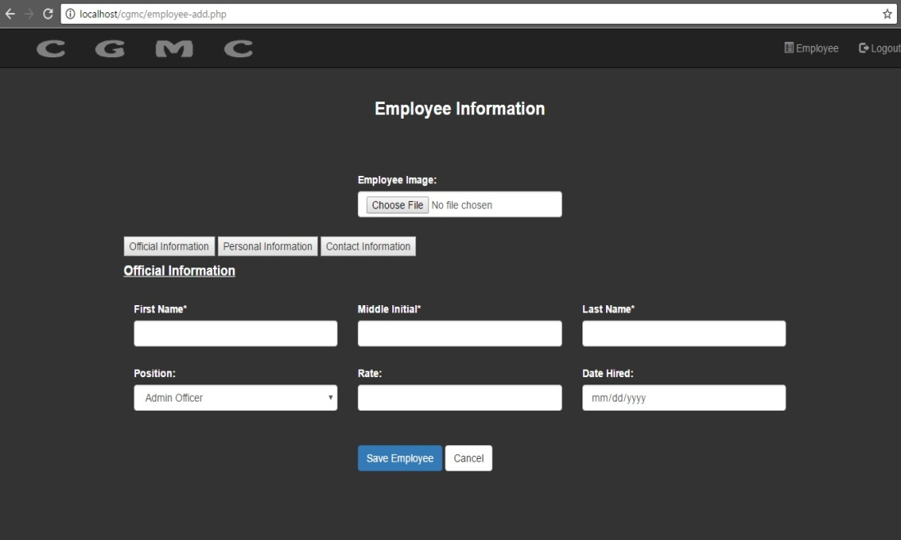

2nd tab Personal information

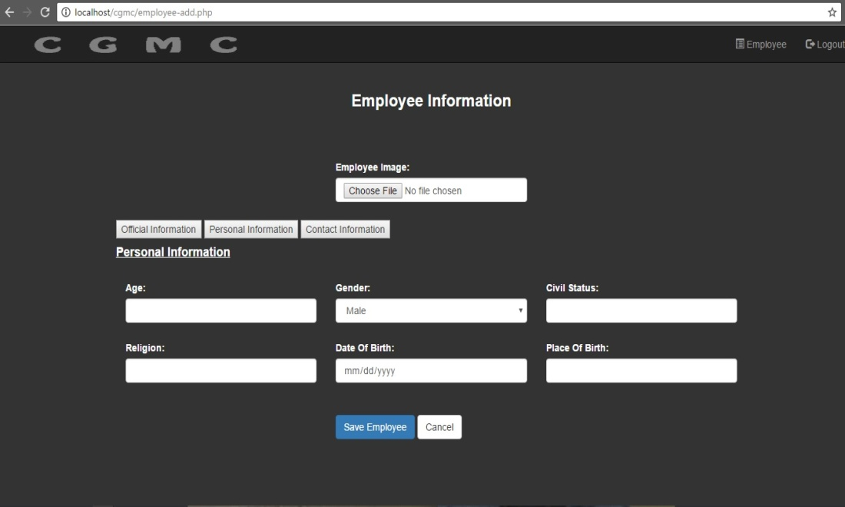

3rd tab Contact information)

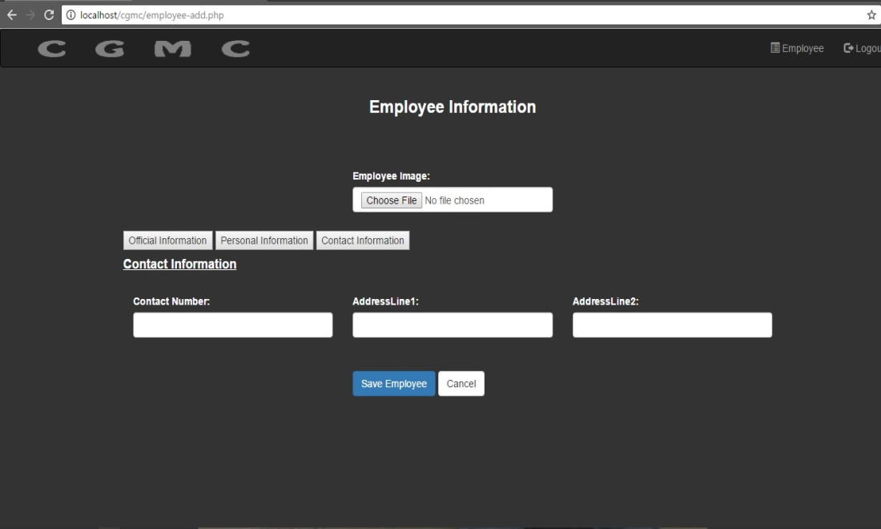

Step3: After filling information, click the button Save Employee to save to database.



1. Edit record, the admin must able to access the View Information were the admin can edit the basic information of the employee. Procedures are:

Step1: Click View Information



Step2: Click Edit Button



Step3: You can now edit information.

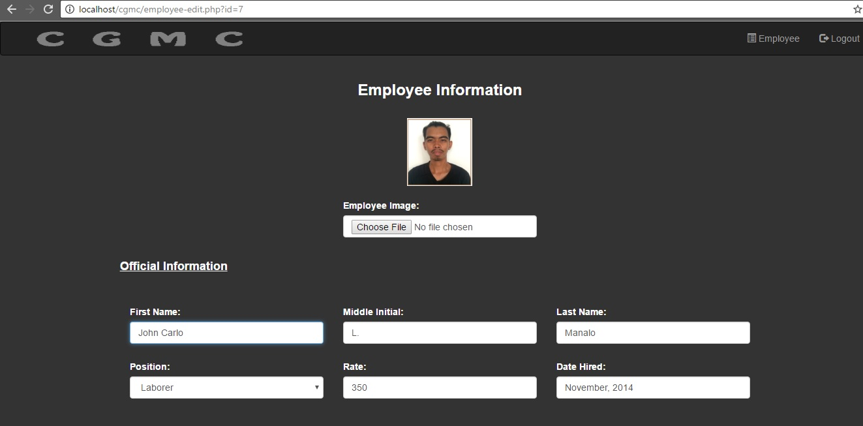

Step4: After editing information, click the button Submit to save to database.



1. Deactivate, User must able to deactivate the record of the employee.

Just click the deactivate button.

